Market Overview

Commodity: Wheat

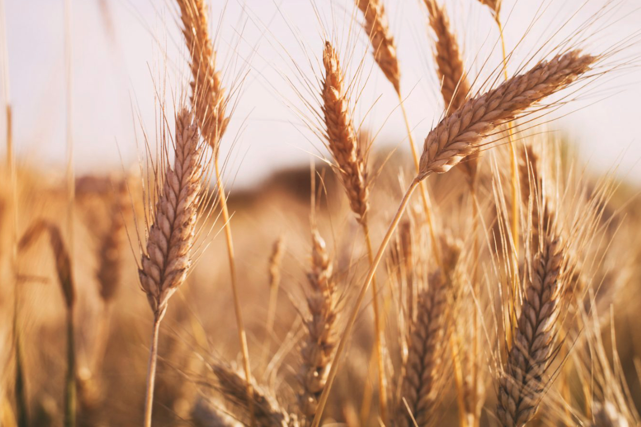

Written by :
Lyticia W., Pirath P., Christopher D.

History
Nowadays, wheat is one of the three cereals produced in the world. This cereal is also a staple food for millions of people around the world. The first wheat crops appeared 10,000 years ago in south-eastern Turkey. This cereal comes from the grass family. Together with rice, the wheat is the main cereal consumed in the world. Over time, wheat varieties have evolved according:

- natural reasons (global warming),
- The evolution of the soil,
- production techniques
- changes in human taste and nutrient intake

Market structure
Currently, international wheat trade averages 135 million tons per year. Without a doubt, wheat is still by far the most traded cereal on the international market. During the 1980s and 1990s, wheat trade volumes had stabilized somewhat, but are now starting to rise again, with an increase of a third between 2000 and the beginning of 2010.

The main importers of this commodity are mainly in: North Africa (Egypt, Algeria ...), the Middle East (Iraq ...) as well as East Asia (Japan, South Korea ...) and South East Asia (Indonesia ...). Despite a huge demand for wheat from over 160 countries,
the offer remains very concentrated economically and geographically. The main exporters are the United States, China, India, Canada, Russia and some countries in Europe.

The biggest companies that control the grain market in the world are mostly the following:

- ADM (Archer Daniels Midland), a corporation based in the US and based in 75 countries.
- Bunge, founded in the Netherlands with its headquarters in New York
- Cargil, based in the United States.
- Glencore International, Anglo-Swiss multinational with about one-tenth of the grain market.

In Switzerland, many companies are dealing in the trade of this commodity. But the main companies that are most present on the market are:
- Allegrow
- ETC Export Trading Company SA
- INFACO Grain Company SA
All of them are based in Geneva.

Important key drivers
As mentioned below, the wheat is influenced by many key drivers but the most important and common are the follow:

- Energy: Indeed, by increasing the energy costs imply increased production costs for wheat and higher costs for transporting the wheat to market. Energy represents a large share of operating costs for most crops. This is especially true when considering indirect energy costs for fertilisers, as fertiliser production is extremely energy-intensive and needs large volumes of natural gas. For certain crops - including wheat - the combined cost of energy and fertilisers accounts for more than half of total operating costs in the United State.

- Revenue growth: It is true that higher incomes lead to greater wheat consumption, particularly in developing countries where caloric consumption is more sensitive to income growth. Furthermore, consumers in developing countries adapt their diets to the new wealth, by eating proportionally more meat and less grain. This change in diet diverts cereals to animal feed. Approximately 15-20% of wheat production is consumed as animal feed.

- Weather: The weather is of course one of the most important key factors. It has a strong impact on crop yields and thus on global agricultural production. The wrong type of weather at the wrong time in the planting cycle, even if it is not prolonged or extreme, can also have some negative effects on the yield of certain crops.

- Substitution effect: Because wheat and other grains are close substitutes, a rise in the price of corn, for example, could result in a corresponding rise in the price of wheat. If the price of corn increases too much, producers begin to move from wheat to corn, decreasing the growth in wheat supply. In the meantime, consumers may switch in the opposite direction and increase their demand for relatively cheaper wheat.

- The US Dollar: Like most commodities traded internationally, wheat is valued in U.S. dollars. In principle, a decrease in the value of the U.S. dollar relative to the currency of the buyer of a commodity implies that the buyer will have to spend less of his own currency to purchase a given quantity of that commodity. As the commodity becomes cheaper, the demand for that commodity increases, resulting in a higher price, and vice versa. A lower dollar can also discourage farmers to increase production.

- Government: Since wheat is one of the main sources of food, governments in developed and developing countries may attempt to restrict the supply of wheat or build up stocks in order to support domestic farmers and/or their consumers.
Governments can also intervene to restrict the export of certain key food commodities, often when fears of domestic shortages and/or high prices are highest. However, these measures generally only aggravate the situation. By reducing the amount of wheat available on the world market, prices are likely to rise further.

Trade Flows

Production of wheat
Wheat is grown to some extent on every continent, except Antarctica.
To begin with, in Asia, China and India are the two top countries who produce the most wheat globally. China’s production of wheat is about 135 million tonnes whereas India’s production is about 103 million tonnes. In addition, Russia is placed third globally with a total of production of 77 million tonnes.
In North America, United States produces 50.8 million tonnes of wheat and is ranked fourth worldwide. Also, Canada produces around 34 million tonnes and is ranked sixth. Furthermore, the largest producer in EU is France who is ranked fifth globally with a sum of production of wheat of 40 million tonnes.
In the middle East, Turkey is the largest producer in the region with 20 million tonnes. Additionally, in the Southern Hemisphere, Australia who is ranked ninth globally has a total wheat production of 24 million tonnes. And, Argentina who is ranked tenth worldwide has 21 million tonnes production of this commodity.
In the year 2020, the updated forecast of FAO indicates that global wheat production will reach 758.3 million tonnes. Compared to previous years, there is a slight decrease of 0.5% but still is at a fairly high level. In addition, even though there are major concerns about the COVID-19 pandemic, it is not expected to have a tremendous impact on wheat production this year.

Imports of Wheat
In 2019, the total international purchases of imported wheat were estimated at a total of US$39.4 billion. Moreover, since 2015, there has been an average drop of -7.1% at the overall cost of imported wheat for all buying countries as it was equalled to US$42.4 billion
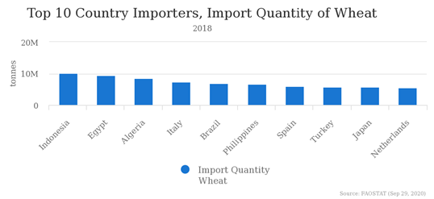
The figure below shows the top 10 country importers of wheat in 2018 according to Food and Agriculture Organization of the United Nations.

Exports of Wheat

Globally, in 2019, the total amount of wheat exports by country was estimated at US$39 billion. In addition, from 2009 to 2019, there has been an increase in its value at an average annual rate of +2.9% over the last ten years.

The figure below shows the top 10 country exporters of wheat in 2018 according to Food and Agriculture Organization of the United Nations

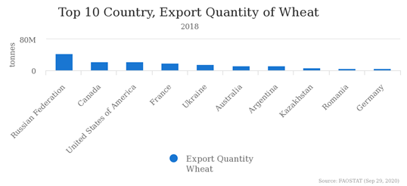

Transportation of wheat
Wheat is one of the most difficult and dangerous types of cereal to transport. Primarily, it starts out on a farm where wheat is harvested and stored locally or transported by a truck to a storage elevator. From there, the wheat is moved into a railcar and shipped to port where it is offloaded and then reloaded to another storage elevator, commonly by conveyor belts.
At that point, the grain is collected until there is enough load for a merchant ship. At the other end of the transportation, the process is reversed, and the grain is offloaded from the ship into another storage elevator. Eventually, it will be shipped to a flour mill or feed compounder for further storage. Then, it will move to a grinding facility via a conveyor or an air slide. The finished products are packed for the market or shipped in bulk to other end users.

Specification

Different types of wheat
Wheat is mainly classified according to its growing season and there are two categories of wheat which are Winter Wheat & Spring Wheat. Winter wheat is planted in the fall and harvested in the spring. This category actually represents approximately 75% of wheat grown in the United States. On the other hand, Spring wheat is planted in the spring and harvested in late summer or early fall.
Furthermore, the table below specifies different ok t types of wheat according to its hardness, colour and shape of its kernel.
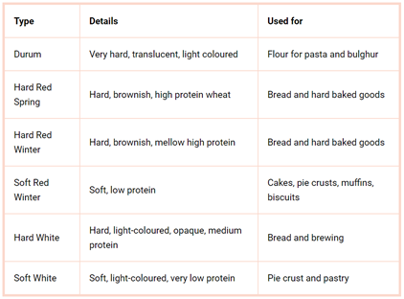

What is special about it ?
Wheat is an important element in a human’s diet as it provides energy thanks to its carbohydrates found in bread and other foods made from wheat. It also provides other nutrients such as fiber magnesium, vitamin B, etc. Also, the genetic components of wheat have not changed in years. And, in fact, wheat won a Nobel Peace Prize. Meaning that, in 1970s, Dr. Norman Borlaug was awarded for his work to develop high-yielding varieties of grain that are credited with saving over a billion people from starvation

Price

The price of the wheat is subject to many variables in demand and the supply side such as the import, weather, past prices, the current stock, production, acreage etc. The demand of the grain is clearly increasing over the years mainly because of the increase of the world population and the wealth of developing countries (see below). On the other hand, the supply side has been also increasing to reach the demand.

Supply factors

- The weather affects the price directly. Depending on the harvest the supply could be low or high.

- Beginning stock is the harvest of the previous year which is carried out to the following year. Therefore, the stock could affect the price.

- The ethanol subsidies were implemented by the USA to boost the production of ethanol which required corn. Therefore, farmers preferred to cultivate corn at the expense of wheat, which influenced the price of this commodity.

Demand factors :

- Population growth is relatively slow in developed countries. Nevertheless, in emerging markets, they are experiencing a huge demographic growth.

- The trend is also affecting the price. More and more people eat gluten free food which is new for traders and producers. Indeed, historically they were only worried about the supply as the demand curve is relatively constant.

Here below, we can see the price of the wheat since last year beginning till June this year. Due to the COVID-19, the price will keep quite high in response to different production issues across the world. The production is assumed to decrease in the EU which will keep the price up, even though the Australian market announced to have had an exceptional harvest this year. Another key factor of the price is the US dollar exchange rate. In fact, the commodity depends a lot on export and import and the main currency used is the US dollar. Therefore, the weaker the currency is the price will have a tendency to be low in the short term.

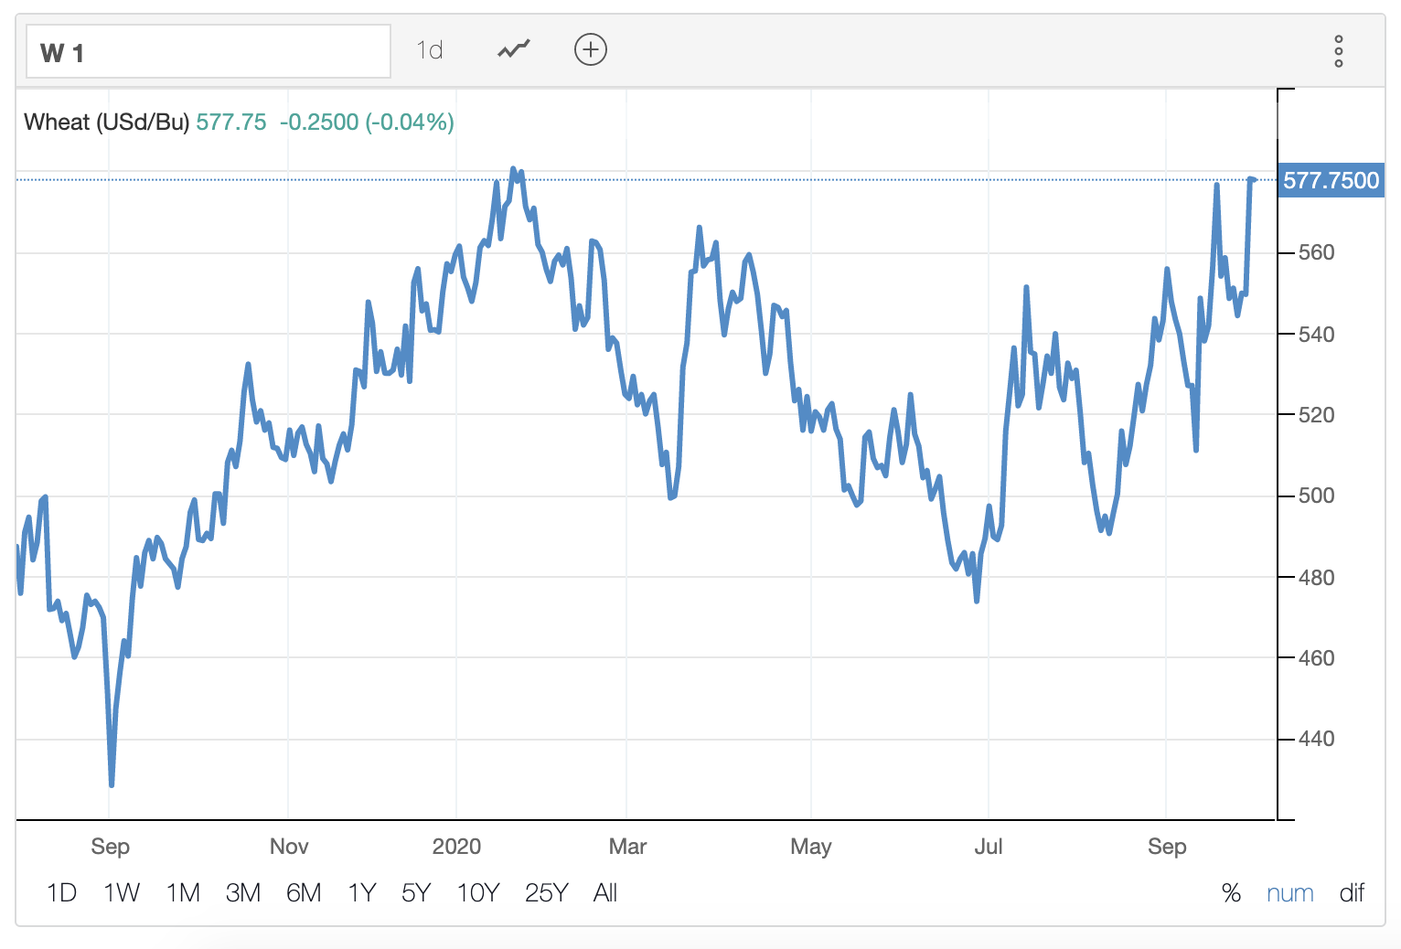

Sources
https://www.hindawi.com/journals/ija/2017/3931897/
https://www.uswheat.org/market-and-crop-information/supply-and-demand/
https://www.ers.usda.gov/webdocs/publications/47264/51088_tb1878b.pdf?v=0
https://capital.com/wheat-price-forecast
https://tradingeconomics.com/commodity/wheat

https://www.alimentarium.org/fr/savoir/blé
https://materials-risk.com/wheat-prices-top-10-important-drivers/
https://www.yara.fr/fertilisation/solutions-pour-cultures/ble/histoire-developement-culture-ble/
https://www.researchgate.net/publication/233417342_6_%27Structure_of_the_World_Wheat_Market_Some_Implications_for_Strategic_Trade_Policy%27_Journal_of_Quantitative_Economics_Volume_8_No_2_New_Series_July_2010_pp_142-158
http://www.alegrow.net
https://www.independent.co.uk/news/uk/home-news/big-five-companies-control-world-s-grain-trade-8462266.html
https://www.etgworld.com
http://www.ifaco-grain.ch/?lang=en
https://sustainablefoodtrust.org/articles/a-brief-history-of-wheat/
https://www.treehugger.com/how-wheat-changed-world-4863756
https://www.britannica.com/plant/wheat
http://www.snv.jussieu.fr/bmedia/blepain/1ble/12orig/origine.htm
Figure 1 : http://www.fao.org/faostat/en/#rankings/countries_by_commodity_imports
Figure 2 : http://www.fao.org/faostat/en/#rankings/countries_by_commodity_exports
Table1 ::https://www.skuld.com/topics/cargo/solid-bulk/agricultural-cargoes/transportation-of-wheat/
http://www.worldstopexports.com/wheat-imports-by-country/
https://www.worldatlas.com/articles/largest-wheat-producing-countries.html
https://www.globaltrademag.com/global-wheat-production-to-reach-758-3m-tonnes-in-2020/
https://dontwastethecrumbs.com/the-different-types-of-wheat-and-what-theyre-used-for/
https://www.namamillers.org/education/six-things-everyone-should-know-about-wheat/

Food and Agriculture Organization of the United Nations

